Installing SQL Server 2005 Express

SQL Server Express is an excellent freeware offering from Microsoft which offers most of the features of Microsoft’s commercial editions of SQL Server. It is an excellent application for testing or proofing out enterprise database solutions. Of course, it is an excellent application for learning how to use a world class database.

If you already have another version of SQL Server then you won’t need to install this. Otherwise, most of us will need to follow the steps in this document to get it running. Mostly everything you need, if not everything, can be downloaded from:
http://msdn2.microsoft.com/en-us/express/bb410792.aspx

This document may be large but it is mostly just a bunch of screenshots. The install is actually fairly simple. There are a couple of dialogs to watch for like Feature Selection and Authentication Mode which will have an impact on your install. Please pay close attention to these dialogs to ensure you have the recommended settings. After you have everything downloaded, the actual install won’t take you very long.

If you encounter any difficulty during the install and get stuck, please post your issues to the SQL Server Express discussion group on WebCT. If you discover some great feature or have any advice on how to use it please post your tips to this discussion group as well.

Install Pre-Requisites

Before installing MS SQL Server 2005 Express there are some pre-requisite items that you will need to download and install as well. Fortunately these are downloadable from the same page as SQL Server Express:
http://msdn2.microsoft.com/en-us/express/bb410792.aspx

The additional items you need are:
- .NET framework 2.0
- MSXML 6.0
The links to these items and to the MS SQL Server Express 2005 downloads are shown in screenshots below:
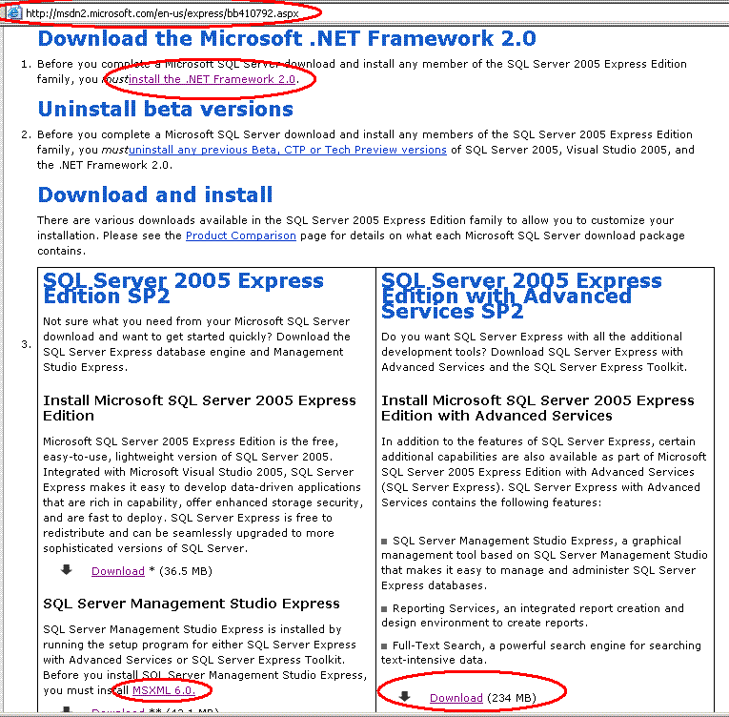

Once your system is ready for the SQL Server 2005 install, download it and double-click on the installer file. Advance through all default screens until you reach the Registration Information dialog. To keep things simple, if you are new to this install enter a name for your install and select hide advanced configuration options.
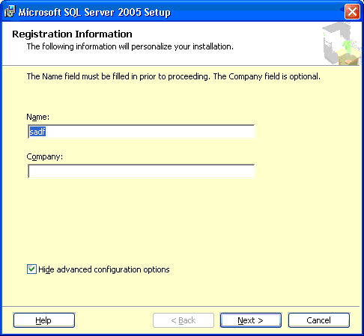

Click Next to advance to the next screen.
The Feature Selection dialog allows you to choose the client and server components. All available database services are needed to run your server and to have flexibility later when working with your server including all Client Components is also recommended.

You should see the Management Studio Express option as one of the client components. This option is essential for us since it provides a user friendly interface for managing your databases.
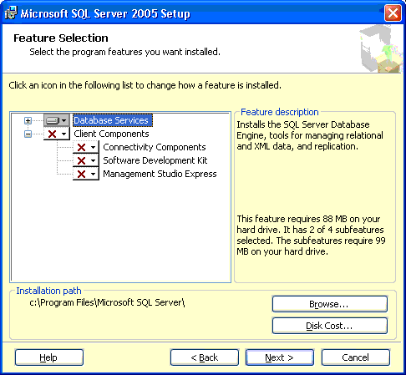

If you do not see the Management Studio Express option, you can download it separately from http://msdn2.microsoft.com/en-us/express/bb410792.aspx and then install it. However, only do this if it isn’t part of your initial install.

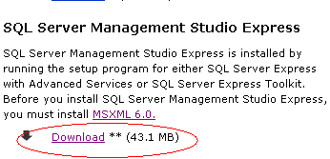
In the Feature Selection dialog, ensure all components are selected. This can be done by placing the mouse cursor over the component selector which appears as a drop-down menu.
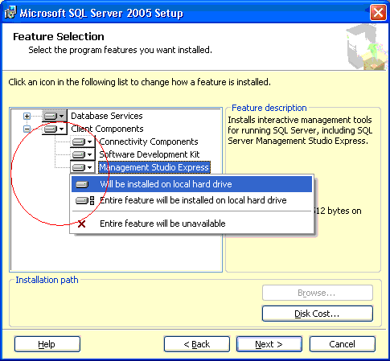
Unless you are a Windows authentication expert, and most of us are not, I strongly recommend using Mixed Mode when choosing an Authentication Mode.

A strict password will be enforced. You can choose anything that passes Microsoft’s restrictions with the right mix of lowercase, uppercase, and numeric characters. If you have a tendency to forget passwords you could use the same one I did which is Abc123. This password is case specific.
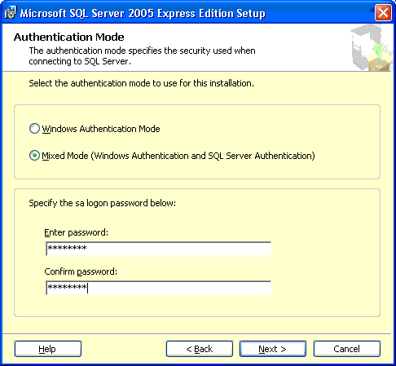

Once you have finished selecting Mixed Mode and entering your administrator password click Next to advance to the next screen.
The options here are Windows authentication specific for the Windows admin experts. I
recommend using the defaults here unless you know what you are doing.

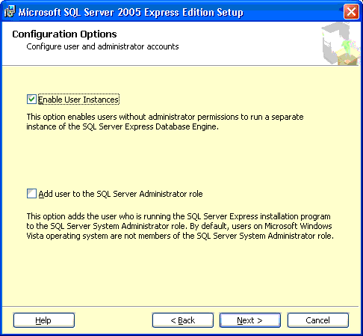

When you advance to the next screen, you can opt to send your error messages to Microsoft. If you are uncertain about what kind of information you may or may not want to send then leave these choices unselected and click Next.
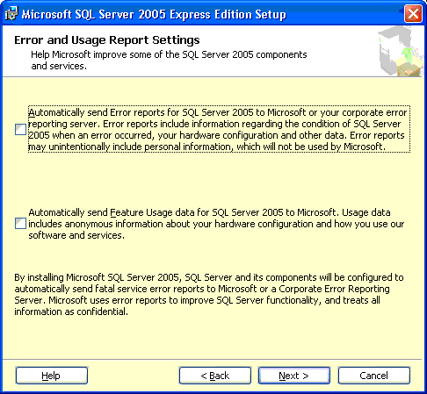

From this point forward you can advance through the remaining screens and accept the default settings. The last dialog should inform you that the install has been successful and that you can click Finish.

